**THERE WAS AN OLD WOMAN WHO LIVED IN A SHOE**

[GO BACK](https://www.thecuriosityapproach.com/curiosity-crib/autumn/invitation-to-learning)

**Autumn**

There was an Old Woman who lived in a shoe.. she had so many children she didn't know what to do...

 This Invitation to learning can provoke lots of language, mathematical skills, imagination and creative thinking. The different sized clogs, the range of wooden pegs to represent 'people' all teamed with the number stackers. All of these items can be counted, sorted by size, height, weight and by similarities, and that's not all the book itself is a prompt.

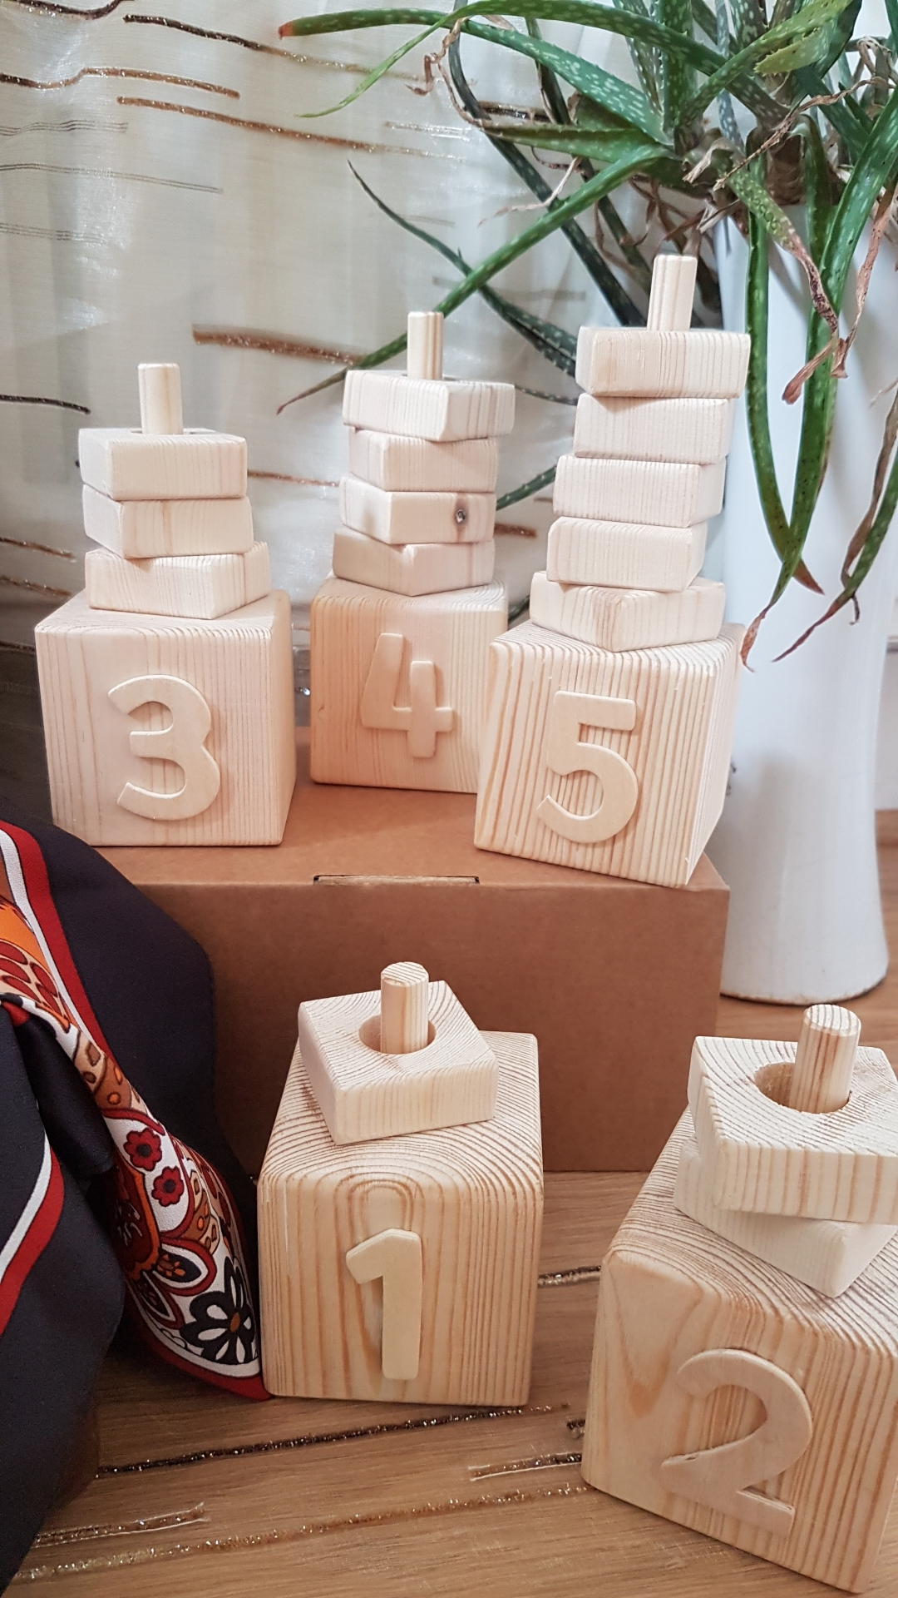

The book is a traditional tale, not only does it provides a rhyming rhythm for children to hear, and the opportunity to discuss families, everyone's families are different. They can be made up of people from different cultures, races and relationships. Families are created when people who love each other and want to care for each other together.

During September most nurseries and schools have a new intake of children, children and their families cope with this transition in their own ways, this invitation to play could provide the opportunity to learn more about the children,  their families and people who are important to them.

Recipe

* A suitcase or a basket to display the clogs and resources in.
* Number stackers from John Coverdale link [here](https://www.facebook.com/pg/John-Coverdale-Gardening-and-Educational-Woodwork-Projects-1506316362782933/photos/?ref=page_internal)
* A collection of clogs, these have been sourced and collected from Charity shops
* Wooden peg people, different sizes link here
* Dolly pegs link [here](https://www.amazon.co.uk/gp/product/B002ABMSH0/ref=as_li_tl?ie=UTF8&camp=1634&creative=6738&creativeASIN=B002ABMSH0&linkCode=as2&tag=thecuriosit0b-21&linkId=f5f35c5a1a4c477b8eedec0e96d1570a)
* A beautiful Autumnal coloured silk scarf and a plant bringing life to the area all sets the scene for discovery and play.

