**DEEP LEVELS OF LEARNING**

[GO BACK](https://www.thecuriosityapproach.com/curiosity-crib/autumn/invitation-to-learning)

**Autumn**

Leuven scales.

Knowing your children incredibly well, helps you instinctively know these levels & we truly TRUST in the process .When we set up an invitation to learning it’s always amazing to see how each child plays with & investigates the items provided.

There are no prefixed outcomes to learning, as we are fully aware that the children will each play, explore & investigate in their own & unique way !

Step back & let the learning evolve. We trust the children in the process of head, heart & hands. 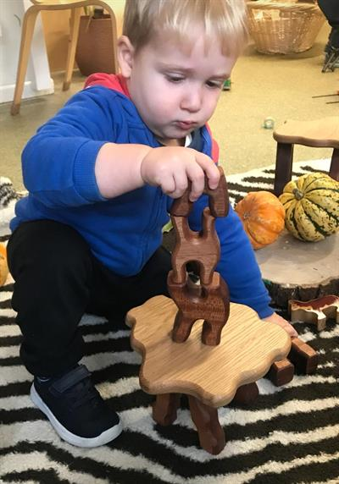

Look at the concentration of the children, their levels of engagement & well being

PLAY is where magic happens.

What are the Leuven scales ?

This tool has been developed by a team based at the Research Centre for Experiential Education (Leuven University – Belgium. Under the supervision of Dr. Ferre Laevers.

The tool focuses on two central indicators of quality Early Years provision: children’s ‘well-being’ and their ‘involvement’.

The high levels of both well-being and involvement allow children to experience deep learning.

A happy, Curious & involved child is one who can experience the world at its fullest. They truly learn from those experiences.

We used this beautiful construction set from from island dreams crafts link [here](https://www.islanddreamscrafts.co.uk/product-page/natural-construction-set)

http://web.plymouth.gov.uk/documents-ldtoolkitleuven.pdf

