**AUTUMN IS IN THE AIR**

[GO BACK](https://www.thecuriosityapproach.com/curiosity-crib/autumn/invitation-to-learning)

**Autumn**

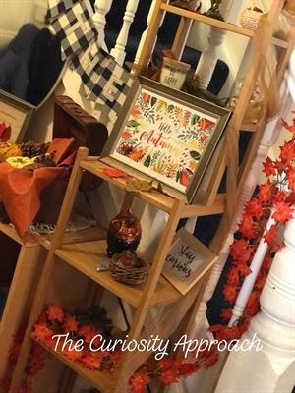As the Summer ends Autumn creeps in and then BANG bursts of colour all around us, from pumpkins to falling autumn leaves, conkers and acorns been squirrelled away by local wildlife collecting their harvest and stocking up for winter. These changes breeze into our lives but how do we celebrate this in our settings? As part of our pedagogy we celebrate the seasons (Steiner) we honour them and ensure our settings and sprinkled with autumnal love.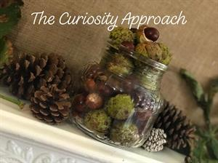

Our environment speaks, she is our third teach and it is important to always make sure she looks her best. Our entrances 'decorated' with autumnal colours through objects such as pumpkins, autumn leaves, ornaments sourced from car boots or charity shops. Fairy lights are added ready to shine in the darker evenings to come and beautiful earthy scents are added to our aromatherapy diff-users. Check out The Holistic Mummy in our Market place for beautiful natural aromatherapy  oils, she can mix any that you want.

How do you celebrate the seasons in your settings?