**Bird seed pizza**

**Autumn**

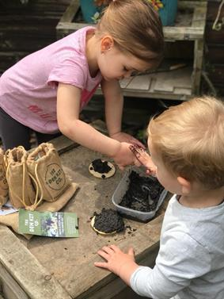

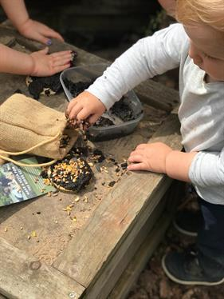

This fabulous kit from The Den Kit Co has everything you need apart from the mud to create your bird seed pizzas. Its a great experience for children to feed the birds in your area in a creative way.

Recipe

* Bird seed
* Wooden tree slices
* Soil
* Water
* Little hands to help
* A spoon or trowel

Mix the soil and water together, this is quite a fun experiment, if you use too much water and the bird seed wont stick as the mud will be too runny, if you you too little water you wont form mud and the mix will be too dry. It provides an opportunity for children to problem solve and work out through experimentation a good consistency.

Once happy with the mud, add to wooden slice and use the bird seeds to decorate your 'pizza'. Allow to dry and then place outside near a tree or hedgerow and observe the birds enjoying this snack.